In order to handle 20-30A peaks and 3A continuous or 6-8A continuous current (depends on motor size and no of drivers) , if we wanted to use bipolar junction transistors we would need to use proper power transistors. But all power transistors have similar disadvantages. For example consider the popular power transistor tip35C—

The tip 35C has the capability to do max 25A which is amazing but it has a very low gain , so in order to saturate it the base current needs to be quite high.

This is the graph for gain

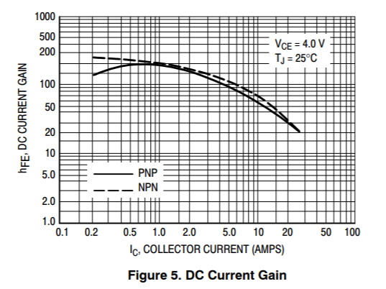

We can see the gain drops ridiculously low at 5 to 10A region. Hence the base would easily need more than 1ampere to saturate the transistor to be operated as a switch . more than 1 ampere would ensure that its turned on HARD and Vce is low as heat dissipated is Vce time collector current very roughly .

So we would need a second transistor to drive the first transistor . which is fine. The issue is that there will always be a resistor at the base of the TIP35C and that resistor will do 1amp or more and hence would have to be a power resistor which is huge, no matter what its ohmic value is. That is highly undesirable. It would be large in size and overall the driver is also larger using power transitors and we need larger heatsinks as they are not much efficient in most cases but comparison is to be done properly.

Also when a motor starts it would draw a huge amount of current. If one driver is used for 1 side then the large current drawn may not be enough to keep it in saturation and it might enter the active region and heat up and drop a lot of voltage across it and also may get damaged and also will give reduced performance.

So as a solution there exists amazing power Darlington transistors which can handle enough amps but still have enough gain so that we can saturate it easily.

For example the TIP140 is a good part which can handle max 10A continuous , so would need 3 drivers for 3 wheels but its good.

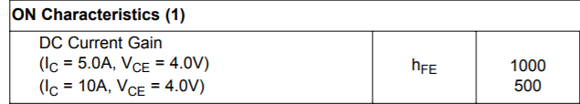

So the gain is good and saturating it into a switch is easy and even in startup of motor it remains saturated and acts as a good switch.

This transistor can be used but its not as efficient as mosfets.

Consider its Vce at 5A

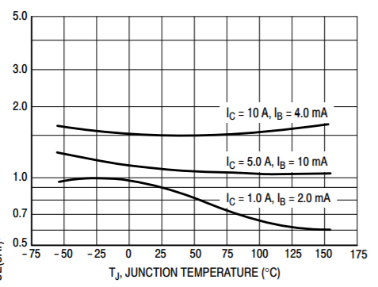

It’s a little bit greater than a volt. So dissipation is roughly 5 to 8watts continuous for such a high load and lower at lower loads like 1amp. So the heatsink would be needed but how large would depend on the continuous load current of the motors selected as that would determine the continuous dissipation. If these are mounted corner to corner like a drawing of h bridge then the 2 heatsinks share the

load.

But mosfets would be a more efficient choice and their peak capabilities are significantly larger.

For example we can use two Nchannel and 2 Pchannel mosfets to make a H bridge that switches.

But P channel mosfets with low ON resistance are more expensive than a same N channel one. Its not like all P channels have very high Rds ON but its just that they are usually more resistive and for a low reistance Pchannel they are expensive.

So we were thinking of using all 4 N channel mosfets. It would help in prototyping , parts ordering and even repair as its just one type of part.

A microcontroller cannot drive these mosfets fast enough as the current punched into base is low and wont charge up the gate fast enough and passing through the region the mosfet would get very hot as its not “FULLY ON” and would heat up on every switching. Thus we need a proper mosfet driver which can punch enough current into the base very fast and turn it on very fast and also remove that charge very fast.

Another reason would be that using a Nchannel mosfet in the high side is hard to do and manually implementing a bootstrap circuit with charge pump is hard. So the driver which can do it wuld help.

Another main reason is that I think its hard to use BJTs with sign magnitude mode as during the PWM off time current would be punched into the lower to transistors with one being improperly biased and might damage the driver. I think if we use BJTs we have to compulsorily use them in LOCKED ANTIPHASE mode , whereas with mosfets we can do sign magnitude easily I think.

We are yet to learn all this analog stuff properly so our choices may change as we learn all this.

For example there are a lot of parts to select for example the flyback diode which I though should be a Schottky but the bootstrap diode should be a very low leakage one like uf4007 which has like 10uA leakage at 1000V rev bias(very good), more diodes to discharge the gate fast by bypassing the gate resistor… lots of things are yet to be learnt to do all this selection , for example even capacitor types and switching parameters of components , more importantly the basics of these components first; are to be learnt.

The selection is made from the knowledge we have so far.

Plus the Nchannel mosfets from Asian semiconductor companies are really good and extremely cheap, for example the 4080K mosfet from NCE (Asian company) is really good with 7mOhm Rdson at 10V gate source and its super cheap at 0.3dollar to 0.2dollars on LCSC. The part is a good part and also happens to be the mosfet on many cytron motor drivers which certifies NCE stuff is not bad. But they are only available in TO-252 package which makes it hard to prototype with them. Other mosfets from NCE are also available in to220…